The Spring City Stove Works
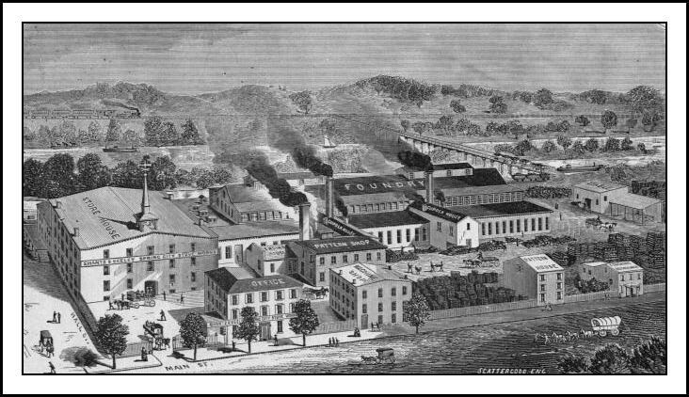
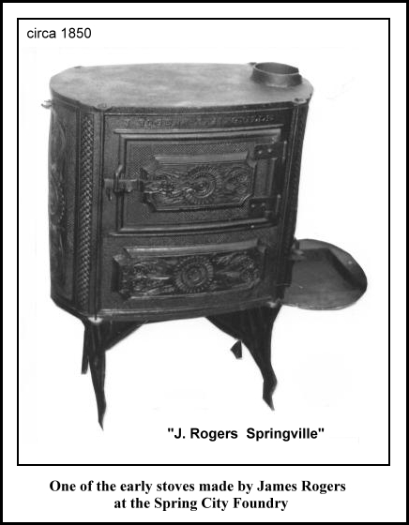
One could certainly make a point that the Spring City Foundry has had the longest continuous running operation of its kind in the area, having been in existence for 162 years. Well, needless to say we would have to redefine continuous since there were several disruptions and reconfigurations over the years. One thing we can accurately say is that a small iron casting business that was started in 1843, in a small town along the Schuylkill River, is still manufacturing cast iron products today.
In 1843 James Rogers built the first stove foundry in this area along the canal in the small town of Springville, now known as Spring City. It was located on the canal slightly north of the current foundry location. The main product was cast iron wood heaters and cook stoves. They also manufactured a full line of hollow ware products such as tea kettles and waffle irons. This was one of the early industries that relied heavily on the canal to ship the finished goods to Philadelphia and beyond. The SFAHS was able to locate and purchase one of these early Rogers nine piece wood stoves and it is currently on display in our museum. A photo of the stove is shown here on the right. On April 30, 1856 a fire destroyed the foundry and caused the plant to close. A passing boatman on the canal spotted the blaze but it burned out of control before help could be summoned.

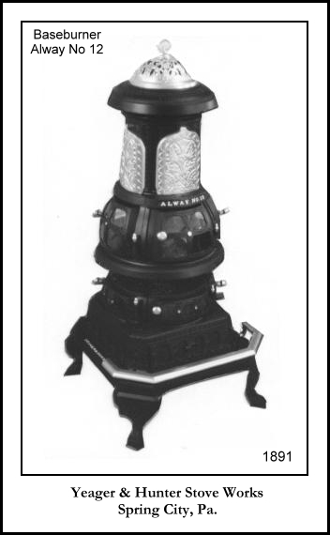
In 1860, three men, Samuel Smith, Casper S. Francis and David G. Wells became partners, and with the support of the local people were able to raise enough capital to build a new foundry near the original site. The new location was actually east of Hall Street on Main where the present day foundry sits. The name of this new company was Smith, Francis & Wells. Five years later, in 1865, Casper Francis left the business and Joseph Johnson came on board and the name was changed to Smith, Wells & Co. The reconfiguration of these small businesses was frequent and sometimes hard to follow. In 1867, David G. Wells sold his interest to Enos S. Shantz and we now had the name of Shantz & Johnson. In 1870 Joseph Johnson sold his interests to Oliver B. Keeley and the new company was known as the Shantz & Keeley Stove Works. The Shantz & Keeley Company prospered and for a decade there was steady growth and stability at the management level. By 1881 there were 225 workers producing 25,000 stoves a year. These products were shipped all over the country. The business had grown so large that they were leasing some buildings in Royersford that were no longer being used by the Buckwalter Stove Co. In 1881 Enos S. Shantz died and Keeley purchased his interests. The company was now known as O. B. Keeley & Co and the Keeley Stove Company. On July 5, 1881 a fire destroyed the Stove Company along with many other buildings along Main Street including the Springville Hotel.
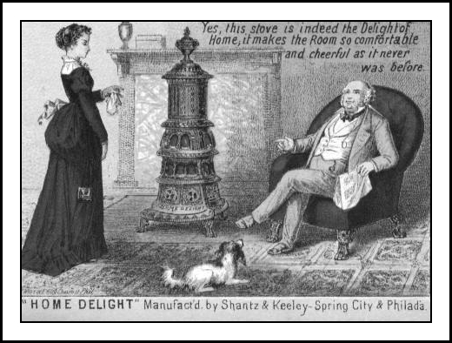
There was no one in the building early that morning as the plant had been closed for the holiday. The cause of the fire was a mystery, but many thought it was started by a steam tug that passed by around 6:00 AM that morning with sparks flying out its stack in all directions. The warehouse, the foundry, the mould shops and in fact all of the buildings except the pattern house had burned to the ground that day. Spring City did not have a fire company at this time.

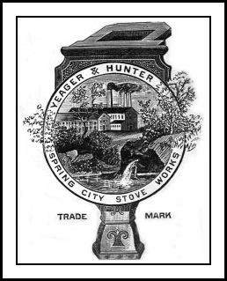
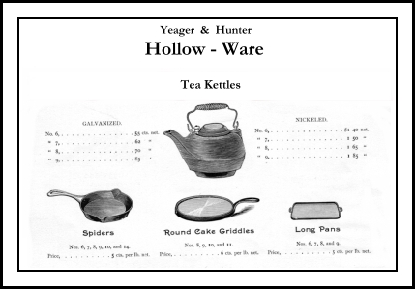
Oliver Keeley continued operations out of the Royersford plant until the following year. On January 1, 1882 he was killed in a train accident in New York. He was 36 years old. This tragic accident would be a temporary setback for the people of Spring City as once again they found their foundry business at a standstill. A group of concerned citizens formed an association with one common goal, to resurrect the stove making industry in the town. In 1883 they erected a large four story stone warehouse, a machine shop, a large foundry, a carpenter shop, an engine shop and an office building. This new construction was at the same site as the previous foundry. A new firm of Yeager & Hunter leased the property that year and again began manufacturing stoves in Spring City. In 1890 the business was incorporated as Yeager & Hunter, Spring City Stove Works. The new owners were Jesse G. Yeager and Francis Hunter. The plant employed over 100 men and several office workers. Yeager and Hunter continued operations all the way through to 1911 when it finally closed. The buildings sat idle for 12 years until 1923 when they were purchased by Morris M. Marcus and Dr. Abe Gross. These men formed the Spring City Foundry Company. The stove manufacturing era in Spring City had officially ended as this new company manufactured various grey iron castings in many shapes and sizes. In 1947 Mr. Marcus set up a new company, The Spring City Electrical Manufacturing Company.

Today the Spring City Foundry is known as the Spring City Electrical Manufacturing Company. They manufacture a variety of products including the street lamp that is shown on this page. Yes, we have one of these lamps right here on our museum property that was made at this local company. If you are interested in their current operation and products you can learn more by going to their web page. Below is a profile excerpt from the homepage for those who do not have access to the internet.

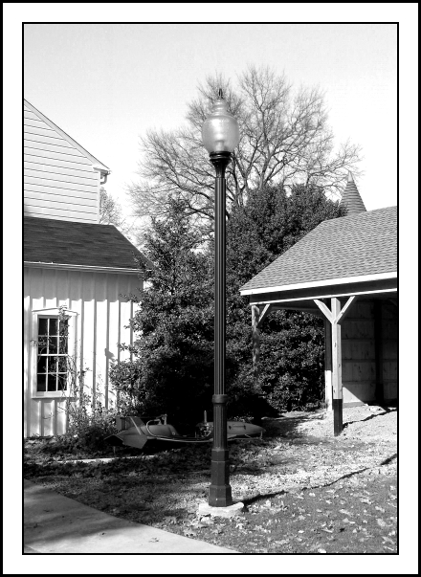
Spring City Company Profile
Spring City is located in Chester County, Pennsylvania, east of the Appalachians. We have been crafting fine cast iron products right here on the banks of the Schuylkill River since 1843, and today more American cities and towns, developments and universities select Spring City for traditional lighting than any other source.
Spring City is a foundry. Our core business is traditional crafted-metal lighting systems, and we have diligently focused our operation so as to manufacture and deliver these systems to you in the fastest, most efficient way possible. Design families include such elements as traffic light posts and arms, posts, cross arms and luminaries for pedestrian and street lighting, lit and unlit bollards, clocks, and street signs, to name only the most often used. And many sites around the country take advantage of additional crafted metal elements such as: stop signs, parking meter brackets, banner systems, sign posts, flagpoles, drinking fountains, wall brackets and more. You can even work directly with our design staff to create completely new custom pieces for your site's particular needs. Contact Spring City Today http://www.springcity.com/index.htm
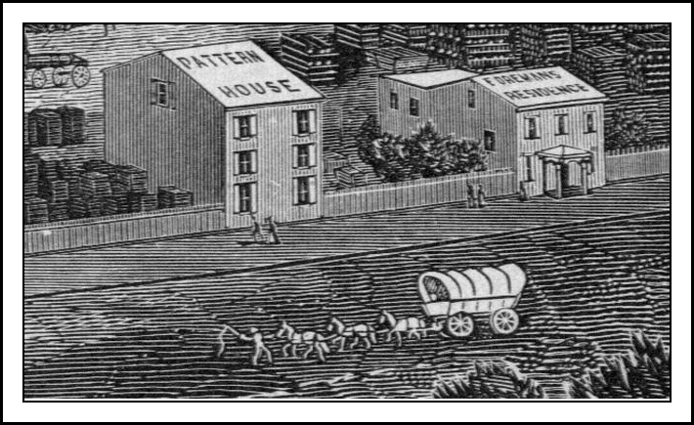

Newsletter Insert
2005

by William C. Brunner

A Saturday Morning History Lesson

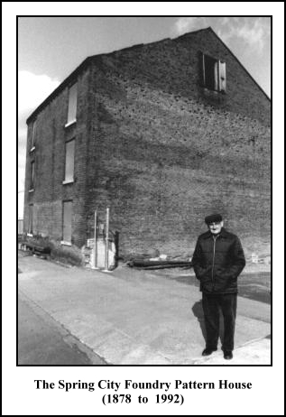
As I paged through my album looking for pictures of the Spring City Foundry for a newsletter story, I came across this photo of Lawrence Shaner standing in front of the old pattern house on Main Street. It was on a Saturday morning fourteen years ago that I got a call from Lawrence. He was very excited as he asked me to come over and join him on a trip down to the pattern house. He said to be sure to bring my camera as I would surely want pictures. You know I had passed this old brick building many times and didn’t even know it was the “pattern house”. What was its significance? I stood there with my camera as Lawrence looked up at the building. He was surely seeing something I couldn’t see. It was like a movie had started but for me the curtains had remained closed. I listened as he spoke about the old stove works and all of the buildings that once stood there. He talked about the fire that destroyed the foundry and how it was rebuilt. He continued to tell me stories about the old stove company. He told me that he had heard from reliable sources that this old building we were looking at was to be leveled to the ground on Monday. The last remaining building of the original 25 that made up this industrial complex had reached the end. Although it had survived the fire of 1881, its time had come. I took a couple of pictures that morning but it wasn’t until years later that I was able to really see what I had taken. I was able to see some of what Lawrence could see that morning. Yes, for me the curtains were finally opened. Now when I stand there on Main Street, in Spring City I can see the Trolley pass by, I can see the smoke coming out of the stacks and I can hear the sounds of the foundry men at work.

